**Experimental study of the peer to peer network**

**Experiment 1: A two peer network sending 1000 requests**

For this experiment we fixed the number of buyer and seller to 1 each, and hence got a two peer network. Once the connection got established the buyer started sending 1000 sequential requests to the seller. We tracked the time taken for each request to complete. Fig 1.1 shows the network itself. Whereas plot in Fig 1.2 shows the graph of time taken for each iteration.

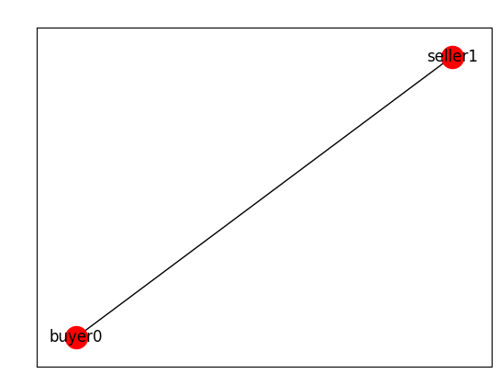

**Fig 1.1 - The two peer experimental network**

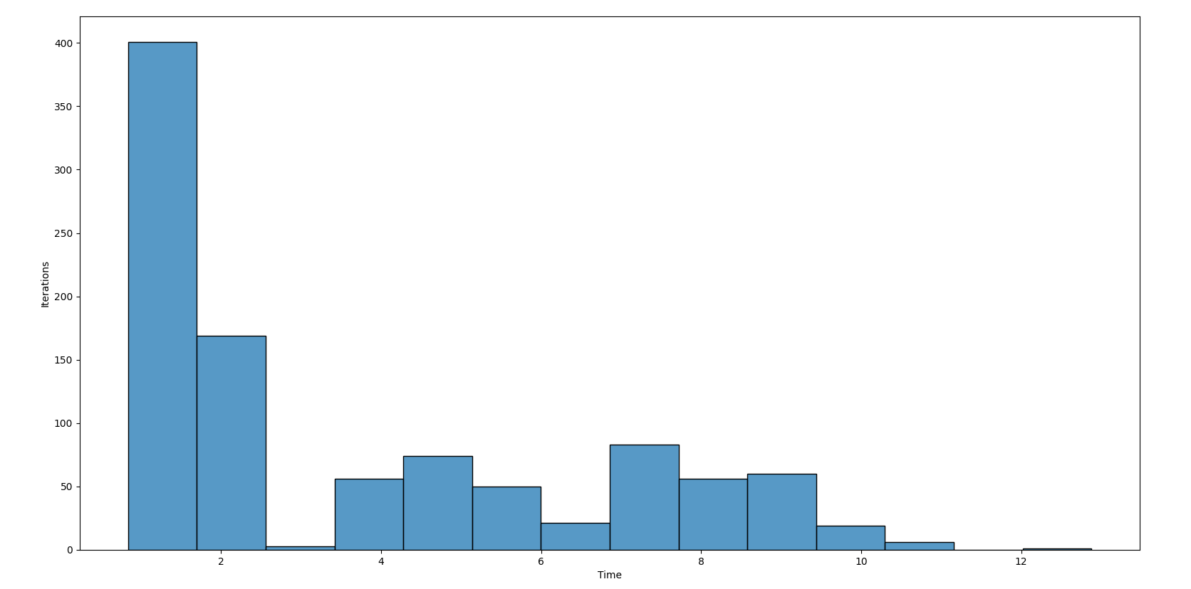

**Fig 1.2 : Iteration vs time (in ms) graph**

From the graph we can clearly see that out of 1000 sequential requests the majority (600) of the request has an average time of less than 2 ms per request. Whereas there are some outlier requests which took almost 12 ms to complete. This might happen due to hardware resources being busy for that particular request. The average time for each request was 3.78 ms.

**Experiment 2: A network with one seller and varying buyers**

For this experiment we created different networks with varying numbers of buyers and a single seller. We experimented with networks of 2, 3, 4 and 5 buyers. One of the networks with five buyers is shown in figure 2.1. we performed the experiment for a total of 20 iterations for each network. The average response time for each network is shown as a histogram plot in figure 2.2 and individual time taken by each peer for different networks is provided in table 2.1

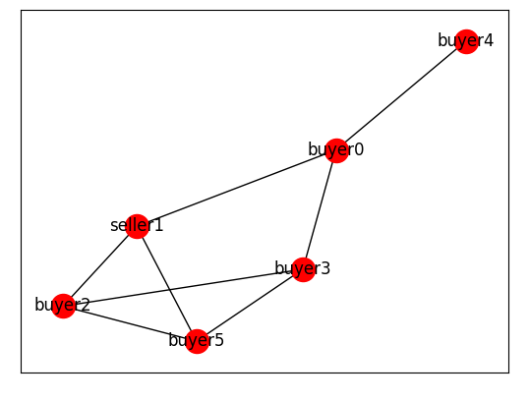

**Fig 2.1 - A network with five buyers and 1 seller**

| **Response time (ms) of each buyer for different networks ( 20 iterations)** | | | |
| --- | --- | --- | --- |
| **Network 1 (2 buyers)** | **Network 2 (3 buyers)** | **Network 3 (4 buyers)** | **Network 4 (5 buyers)** |
| 12.199 | 81.203 | 84.206 | 110.759 |
| 7.198 | 45.04 | 61.05 | 157.328 |
|  | 99.44 | 155.72 | 185.414 |
|  |  | 169.6 | 110.311 |
|  |  |  | 52.744 |

**Table 2.1 - Response time (ms) of each buyer in different network configuration**

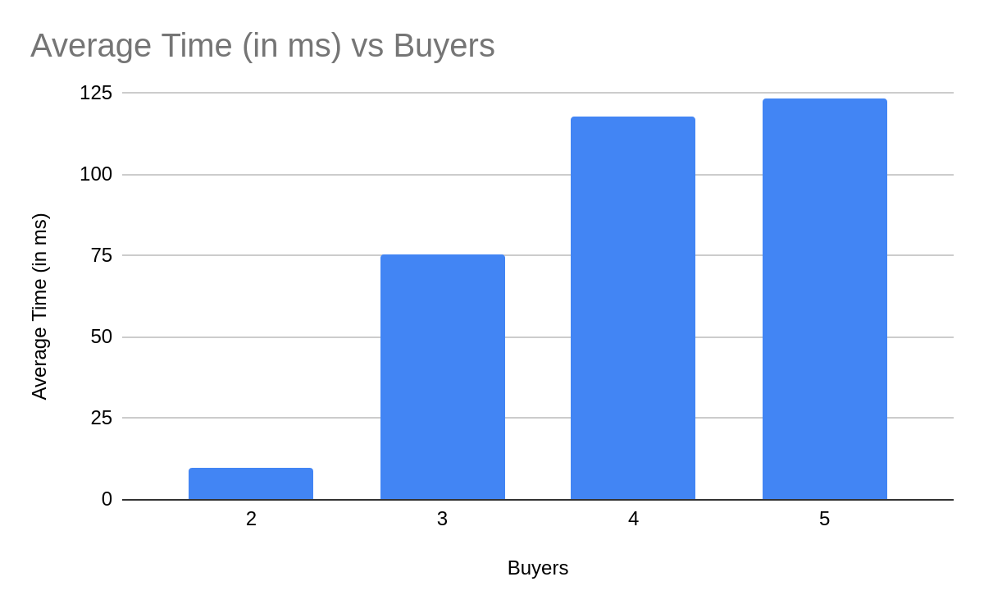

**FIg 2.2 : Average response time for different network configurations**

From the results we can see that average response time increases as more buyers join the network. This is self conclusive as there is only a single seller in the network hence with increase in number of buyers each buyer needs to wait more to get their request fulfilled.